**3rd Grade Georgia Milestone Study Guide**

***Numbers and Operations***

## Place Value

**Multiplication**

537

x 8

## Estimation

Estimate:

500 x 8 = 4,000

The product will be about 4,000

**3 +3 +3 = 9**

or

**3 groups of 3 = 9**

or

**3 x 3 = 9**

|  |  |  |  |  |  |  |  |
| --- | --- | --- | --- | --- | --- | --- | --- |
| Ten thousands | thousands |  | hundreds | tens | ones | decimal | tenths |
| **2** | **6** | **,** | **7** | **5** | **9** | **.** | **3** |

**5x3=15**

**array**

Twenty six thousand, seven hundred fifty nine and three tenths

20,000 + 6,000 + 700 + 50 + 9 + 0.3

(2×10,000) + (6×1,000) + (7×100) + (5×10) + (9×1) + (3x0.1)

**How many tens are in 750?** There is a five in the tens place, but it takes 75 tens to make the number 750, so

4

**Estimation**

**329 + 175 =**

329 is about 300 and 175 is about 200, so the answer is about 500

**Area Model**

**4**

**x**

**1**

**0**

**=**

**4**

**0**

**4**

**x**

**3**

**=**

**1**

**2**

10

+

3

### 40 + 12 = 52

**Change with fewest coins**

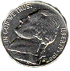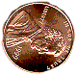

**Making**

**Multiplying by multiples of 10**

**6x7=42 so… 6**0 x **7** = ***42****0*

**488 – 87 =**

488 is about 500

and 87 is about 100, so the answer is about 400

**2x15=30 so… 2**0 x **15**0 = **3,0**00

## Partial Products

## Division

**Identity Property of Multiplication**

* **Any number multiplied by 1 will keep its original value.**

• **23 x 1 = 23, 1 x 8 = 8**

Associative Property of Multiplication

* When multiplying any 3 numbers, changing the grouping does not change the product.

• (3 x 4)5 3(4 x 5)

12 x 5 = 60 3 x 20 = 60

Commutative Property of Multiplication

* When multiplying any 2 or more numbers, changing the order does not change the product.

• 3 · 4 = 4 · 3

12 = 12

Division is the inverse of multiplication

### 12÷4=3 and 4x3=12

Division can be thought of as repeated

39 30 + 9

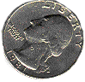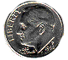

=

x 4 x 4

36 (4 x 9)

+ 120 (4 x 30)

156

subtraction

### 15-3-3-3-3-3=0 so 15÷3=5

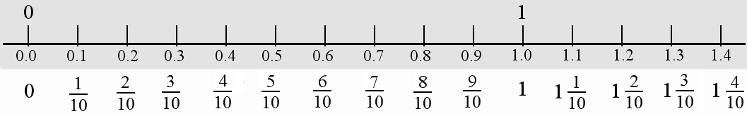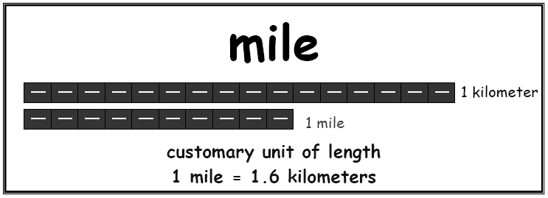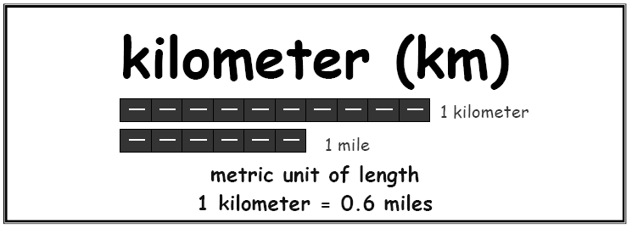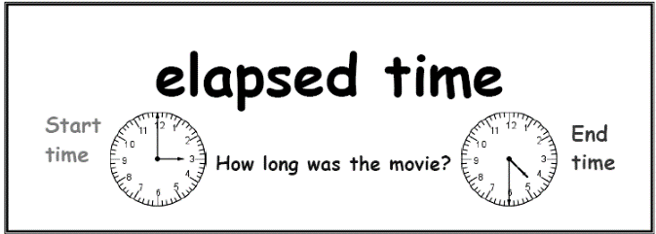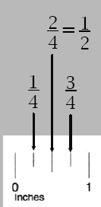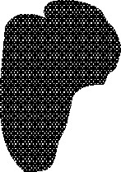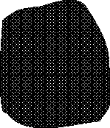

X

X

X

Common fractions are seen and used on a

***Measurement***

daily basis. Examples: 1/4 , 2/3

Decimal fractions have a denominator of

10 and can be written as a decimal. Examples: 3/10 = 0.3 7/10 = 0.7

**Adding**

**and Subtracting Fractions**

**like denominators**

**with**

Measure to the

nearest quarter inch and half inch

10/10 – 3/10

=

7/10

3/8 + 4/8 = 7/8

You would use **kilometers** to measure

the height of a building , but you

would use **millimeters** to measure the length of a ladybug.

|  |  |  |
| --- | --- | --- |
|  |  |  |
|  |  |  |

|  |  |  |
| --- | --- | --- |
|  |  |  |
|  |  |  |

|  |  |  |
| --- | --- | --- |
|  |  |  |
|  |  |  |

|  |  |  |  |  |  |  |  |
| --- | --- | --- | --- | --- | --- | --- | --- |
|  |  |  |  |  |  |  |  |
|  |  |  |  |  |  |  |  |

**Division with a remainder** Joe and his two friends wanted to share 10 apples. How many apples did each person get? Were there any left over?

|  |  |  |  |
| --- | --- | --- | --- |
|  |  |  |  |
|  |  |  |  |

**Partial Quotients –** a mental math strategy

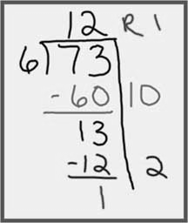

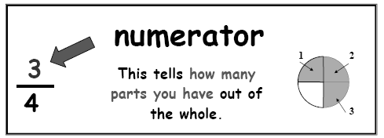

**Fractions**

|  |  |  |  |  |
| --- | --- | --- | --- | --- |
|  | + |  | = |  |
| 2/6 | + | 3/6 | = | 5/6 |

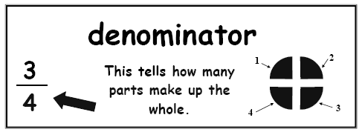

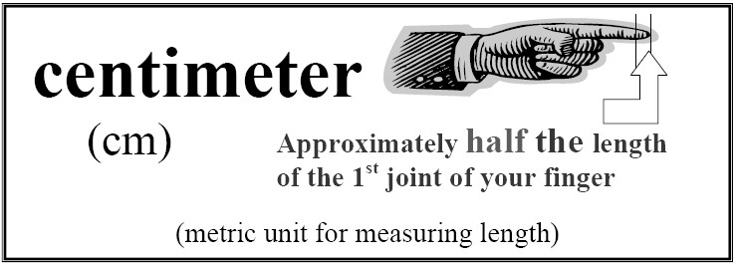

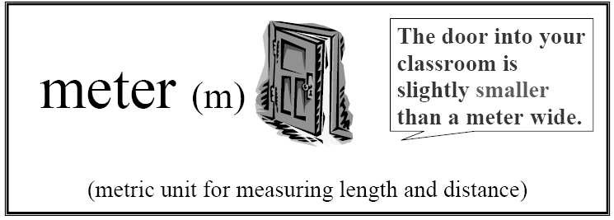**Area 9 sq units**

|  |  |  |
| --- | --- | --- |
|  |  |  |
|  |  |  |
|  |  |  |

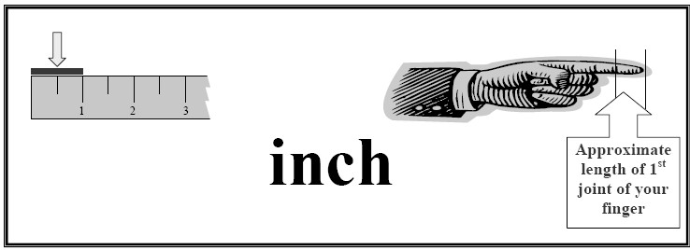Area is the amount of surface space that a flat object has. Area is reported in the amount of square units**.**

# Geometry

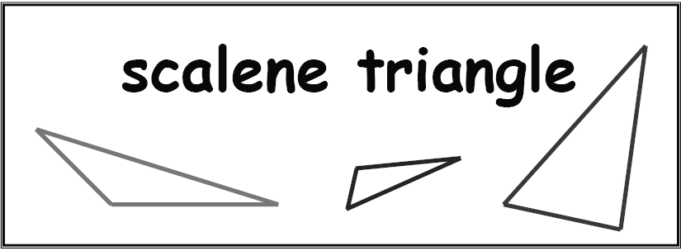

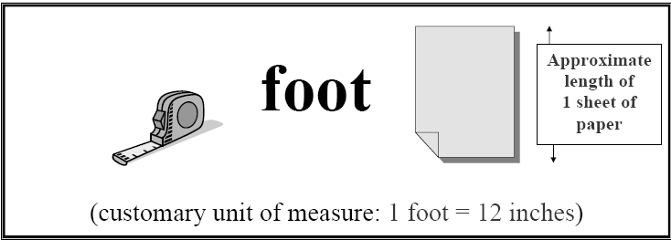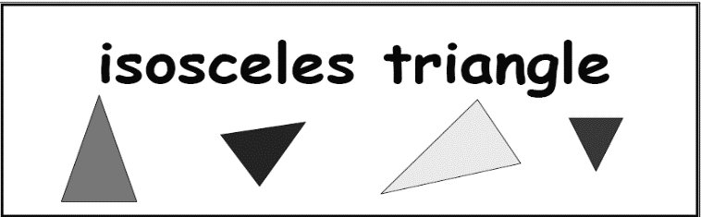All three sides have different lengths

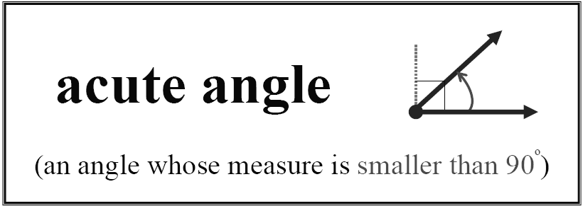

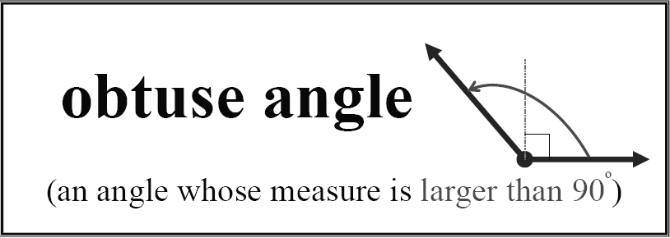

**Diameter:** A line segment passing through the center of a circle with endpoints on the circle.

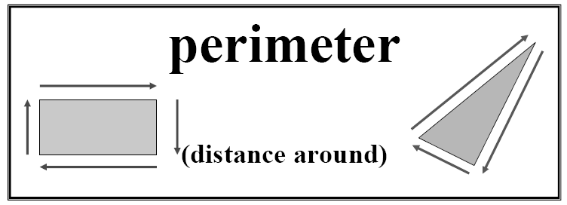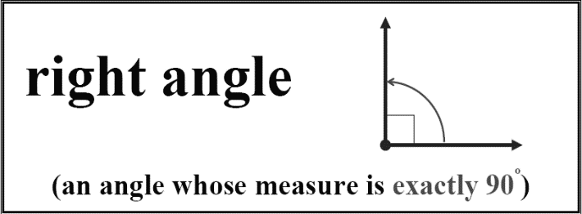

Perimeter is summing the lengths of the sides.

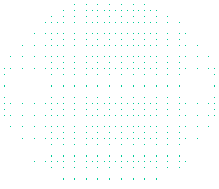

Diameter

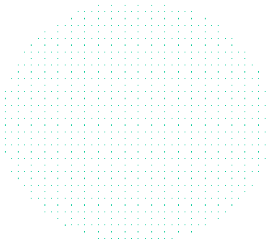

radius

**Radius:** The distance from the center of a circle to any point on the circle.

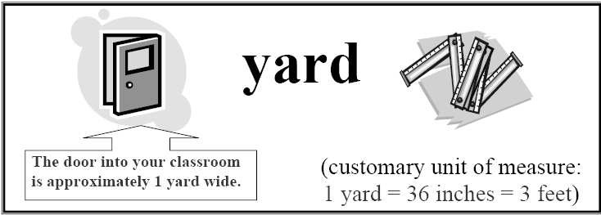At least two equal sides and two equal angles

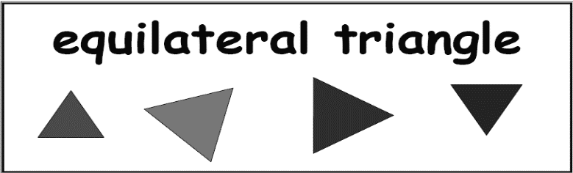

Three equal sides and three equal angles

**Vertex:** The common endpoint of two line segments that serve as two sides of a polygon. (plural:

vertices)

**Side:** A straight line segment that forms part of a polygon

# Algebra

* Patterns can be ***numerical* EX: 2,4,6,8**
* Patterns might be ***geometrical*** as a tile pattern on the floor with 2 blue tiles followed by 1 white tile
* Patterns may also be ***alternating* EX: 1,5, 2,6,3,7,4 (add 4, subtract 3).**

# Data Analysis and

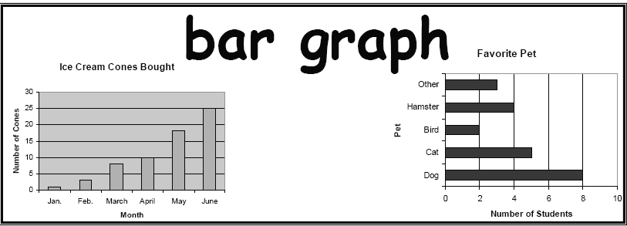***Probability***

* **Bar graph**: A way of displaying data using horizontal or vertical bars so that the height or length of the bars indicates its value.
* **Venn Diagram**: A diagram using circles or other shapes, to show the relationship between sets. Often used in comparing and contrasting.

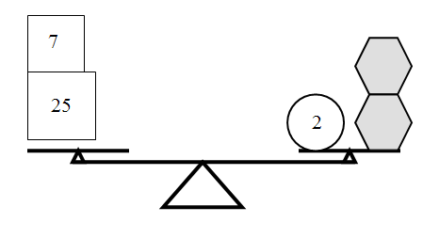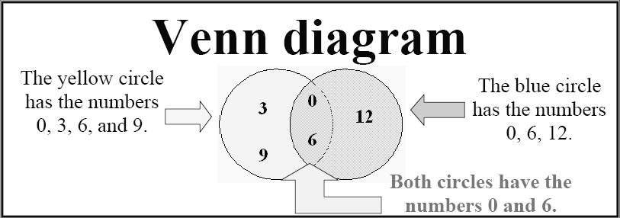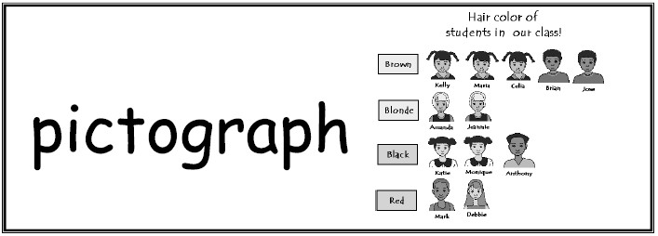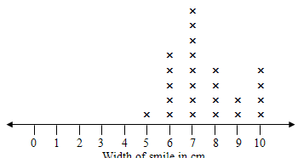

 **+ 3 = 20 or** D **+** D **= 20**

**Line Plot Graph**

32 = 2+

+

32 = 2 + 15 +15

**Growing Pattern**

* **Pictograph**: A graph in which the data is displayed in a table using pictures or symbols, often using a key to explain what the picture represents.
* **Scale**: the intervals that the data will count up
* **Line Plot**: also called a dot plot, uses an “x” to show a piece of data